Lab – Configuring Basic Router Settings with CCP

1. Topology

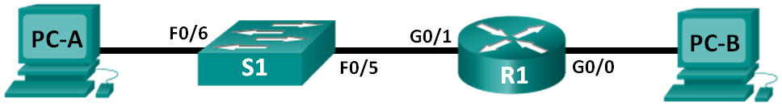

1. Addressing Table

|  |  |  |  |  |
| --- | --- | --- | --- | --- |
| Device | Interface | IP Address | Subnet Mask | Default Gateway |
| R1 | G0/0 | 192.168.0.1 | 255.255.255.0 | N/A |
|  | G0/1 | 192.168.1.1 | 255.255.255.0 | N/A |
| S1 | VLAN 1 | N/A | N/A | N/A |
| PC-A | NIC | 192.168.1.3 | 255.255.255.0 | 192.168.1.1 |
| PC-B | NIC | 192.168.0.3 | 255.255.255.0 | 192.168.0.1 |

1. Objectives

Part 1: Set Up the Topology and Initialize Devices

Part 2: Configure Devices and Verify Connectivity

Part 3: Configure Router to Allow CCP Access

Part 4: (Optional) Install and Set Up CCP on PC-A

Part 5: Configure R1 Settings Using CCP

Part 6: Use CCP Utilities

1. Background / Scenario

Cisco Configuration Professional (CCP) is a PC-based application that provides GUI-based device management for Integrated Services Routers (ISRs). It simplifies the configuration of routing, firewall, VPN, WAN, LAN, and other settings through menus and easy-to-use wizards.

In this lab, you will configure the router settings using the configuration from the previous lab in this chapter. Layer 3 connectivity must be established between the PC running CCP (PC-A) and R1 before CCP can establish a connection. In addition, HTTP access and authentication must be configured on R1.

You will download and install CCP on the PC and then use it to monitor R1’s interface status, configure an interface, set the date and time, add a user to the local database, and edit vty settings. You will also use some of the utilities included in CCP.

**Note**: Router configurations performed using CCP generate IOS CLI commands. CCP can be very useful for configuring more complex router features because it does not require specific knowledge of the Cisco IOS command syntax.

**Note**: The routers used with CCNA hands-on labs are Cisco 1941 Integrated Services Routers (ISRs) with Cisco IOS Release 15.2(4)M3 (universalk9 image). The switches used are Cisco Catalyst 2960s with Cisco IOS Release 15.0(2) (lanbasek9 image). Other routers, switches, and Cisco IOS versions can be used. Depending on the model and Cisco IOS version, the commands available and output produced might vary from what is shown in the labs. Refer to the Router Interface Summary Table at the end of this lab for the correct interface identifiers.

**Note**: Make sure that the router and switch have been erased and have no startup configurations. If you are unsure, contact your instructor.

1. Required Resources

* 1 Router (Cisco 1941 with Cisco IOS Release 15.2(4)M3 universal image or comparable)
* 1 Switch (Cisco 2960 with Cisco IOS Release 15.0(2) lanbasek9 image or comparable)
* 2 PCs (Windows 7, Vista, or XP with terminal emulation program, such as Tera Term)
* Console cables to configure the Cisco IOS devices via the console ports
* Ethernet cables as shown in the topology

**Note**: PC system requirements for CCP version 2.6 are:

* + - * 2 GHz processor or faster
      * 1 GB DRAM minimum; 2 GB recommended
      * 400 MB of available hard disk space
      * Internet Explorer 6.0 or above
      * Screen resolution of 1024x768 or higher
      * Java Runtime Environment (JRE) version 1.6.0_11 or later.
      * Adobe Flash Player version 10.0 or later, with Debug set to No

**Note**: The Gigabit Ethernet interfaces on Cisco 1941 ISRs are autosensing and an Ethernet straight-through cable may be used between the router and PC-B. If using another model Cisco router, it may be necessary to use an Ethernet crossover cable.

1. Set Up the Topology and Initialize Devices
   1. Cable the network as shown in the topology.
      1. Attach the devices shown in the topology diagram, and cable as necessary.
      2. Power on all the devices in the topology.
   2. Initialize and reload the router and switch.
2. Configure Devices and Verify Connectivity

In Part 2, you will configure basic settings, such as the interface IP addresses (G0/1 only), secure device access, and passwords. Refer to the Topology and Addressing Table for device names and address information.

* 1. Configure the PC interfaces.
     1. Configure the IP address, subnet mask, and default gateway settings on PC-A.
     2. Configure the IP address, subnet mask, and default gateway settings on PC-B.
  2. Configure the router.

**Note**: Do NOT configure interface G0/0 at this time. You will configure this interface using CCP later in the lab.

* + 1. Console into the router and enable privileged EXEC mode.
    2. Enter into global configuration mode.
    3. Disable DNS lookup.
    4. Assign a device name to the router.
    5. Require that a minimum of 10 characters be used for all passwords.
    6. Assign **cisco12345** as the privileged EXEC encrypted password.
    7. Assign **ciscoconpass** as the console password and enable login.
    8. Assign **ciscovtypass** as the vty password and enable login,
    9. Configure **logging synchronous** on the console and vty lines.
    10. Encrypt the clear text passwords.
    11. Create a banner that warns anyone accessing the device that unauthorized access is prohibited.
    12. Configure the IP addresses, an interface description, and activate G0/1 interface on the router.
    13. Save the running configuration to the startup configuration file.
  1. Verify network connectivity.

Verify that you can ping R1 G0/1 from PC-A.

1. Configure the Router to Allow CCP Access

In Part 3, you will set up the router to allow CCP access by enabling HTTP and HTTPS server services. You will also enable HTTP authentication to use the local database.

* 1. Enable HTTP and HTTPS server services on the router.

R1(config)# **ip http server**

R1(config)# **ip http secure-server**

* 1. Enable HTTP authentication to use the local database on the router.

R1(config)# **ip http authentication local**

* 1. Configure the router for CCP access.

Assign a user in the router local database for accessing CCP using username **admin** and password **adminpass1**.

R1(config)# **username admin privilege 15 secret adminpass1**

1. (Optional) Install and Set Up CCP on PC-A
   1. Install CCP.

**Note**: This step can be skipped if CCP is already installed on PC-A.

* + 1. Download CCP 2.6 from Cisco’s website:

<http://software.cisco.com/download/release.html?mdfid=281795035&softwareid=282159854&release=2.6&rellifecycle=&relind=AVAILABLE&reltype=all>

* + 1. Choose the **cisco-config-pro-k9-pkg-2_6-en.zip** file.

**Note**: Verify that you select the correct CCP file and not CCP Express. If there is a more current release of CCP, you may choose to download it; however, this lab is based on CCP 2.6.

* + 1. Agree to the terms and conditions, and download and save the file to the desired location.
    2. Open the zip file and run the CCP executable.
    3. Follow the on-screen instructions to install CCP 2.6 on your PC.
  1. Change settings to run as the administrator.

CCP may fail to launch correctly if it is not run as an administrator. You can change the launch settings so that it automatically runs in administrator mode.

* + 1. Right-click the **CCP** desktop icon (or click the **Start** button) and then right-click **Cisco Configuration Professional**. In the drop-down list, select **Properties**.
    2. In the Properties dialog box, select the **Compatibility** tab. In the Privilege Level section, click the **Run this program as an administrator** checkbox, and then click **OK**.

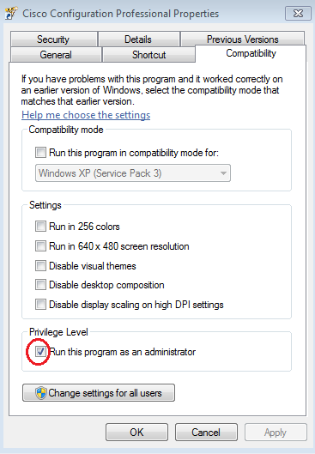

* 1. Create or manage communities.
     1. On PC-A, start CCP. (Double-click the CCP desktop icon or click **Start** > **Cisco Configuration Professional**.)
     2. If you receive a security warning message prompting to allow the CiscoCP.exe program to make changes to the computer, click **Yes**.

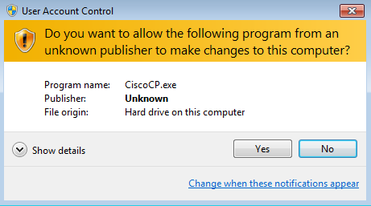

* + 1. When CCP starts, the **Select / Mange Community** dialog box displays. Enter the IP address for R1 G0/1, and the username **admin** and password **adminpass1** that you added to the local database during the router configuration in Part 2. Click **OK**.

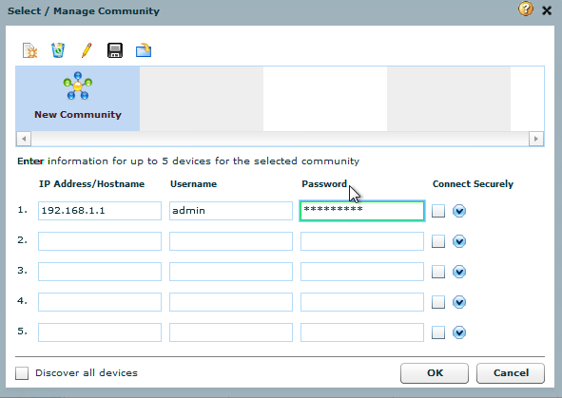

* + 1. In the Community Information window, click **Discover**.

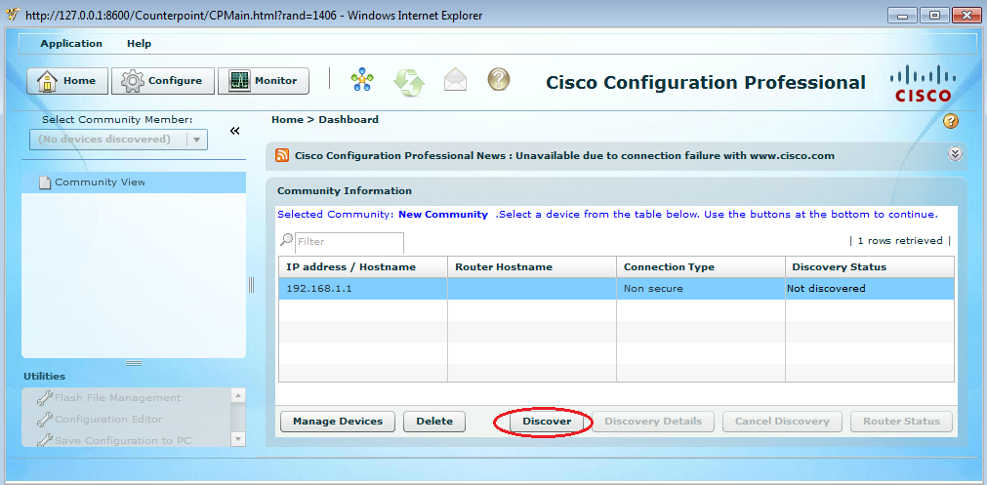

If you have configured the router correctly, the Discovery Status changes from **Not discovered** to **Discovered**, and R1 appears in the Router Hostname column.

**Note**: If there is a problem with your configuration, you will see a “Discovery failed” status. Click **Discovery Details** to determine why the discovery process failed and then troubleshoot the problem.

1. Configure R1 Settings Using CCP

In Part 5, you will use CCP to display information about R1, configure interface G0/0, set the date and time, add a user to the local database, and change your vty settings.

* 1. View the status of the interfaces on R1.
     1. On the CCP toolbar, click **Monitor**.



* + 1. In the left navigation pane, click **Router** > **Overview** to display the Monitor Overview screen in the right content pane.

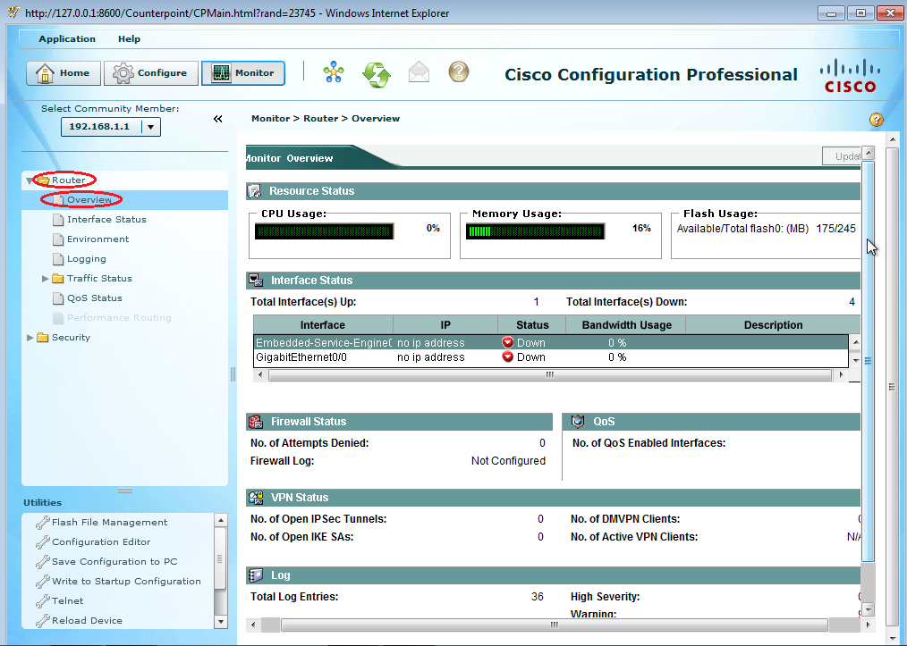

* + 1. Use the up and down arrows to the right of the interface list to scroll through the list of interfaces for the router.

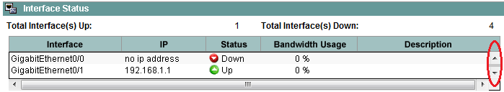

* 1. Use the Ethernet LAN wizard to configure interface G0/0.
     1. On the CCP toolbar, click **Configure**.



* + 1. In the left navigation pane, click **Interface Management** > **Interface and Connections** to display the Interfaces and Connections screen in the right content pane.

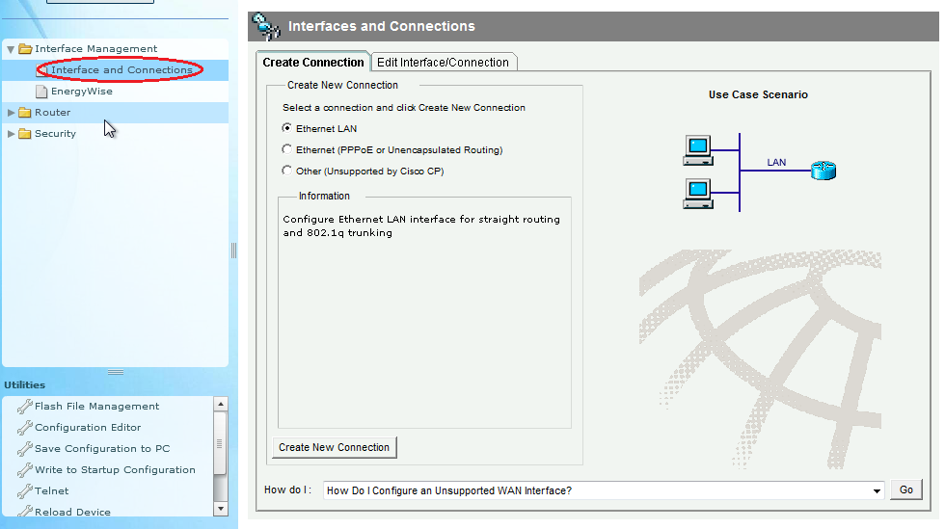

* + 1. Click **Create New Connection** to start the Ethernet LAN wizard.
    2. When you are prompted to enable AAA on the router, click **No**.
    3. Click **Next** to be guided through the Layer 3 Ethernet interface creation process.
    4. Keep the **Configure this interface for straight routing** radio button selected and click **Next**.
    5. Enter **192.168.0.1** in the IP address field and **255.255.255.0** in the Subnet mask field and click **Next**.
    6. Keep the **No** radio button selected on the DHCP server screen and click **Next**.
    7. Review the summary screen and click **Finish**.
    8. Click the **Save running config to device’s startup config** check box, and then click **Deliver**. This adds the commands shown in the preview window to the running configuration, and then saves the running configuration to the startup configuration on the router.
    9. The Commands Delivery Status window displays. Click **OK** to close this window. You will be routed back to the Interfaces and Connections screen; G0/0 should have turned green and displayed as Up in the Status column.

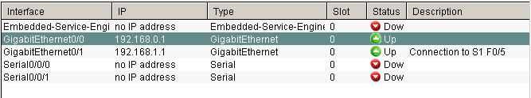

* 1. Set the date and time on the router.
     1. In the left navigation pane, select **Router** > **Time** > **Date and Time** to display the Additional Tasks > Date/Time screen in the right content pane. Click **Change Settings…**.

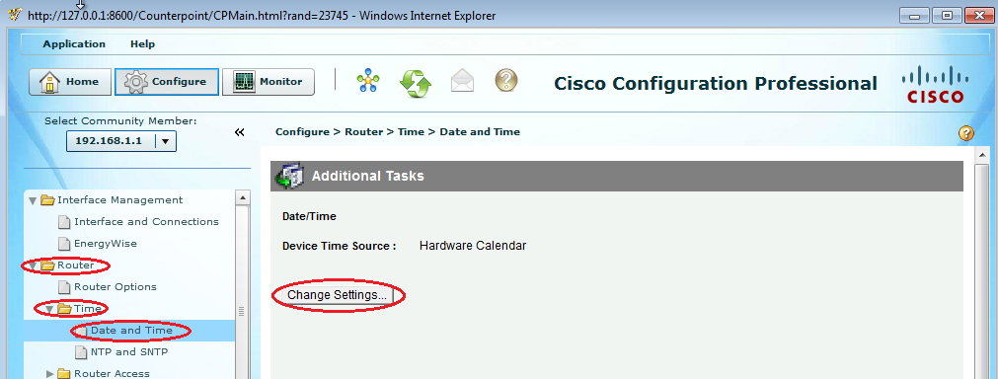

* + 1. In the Date and Time Properties window, edit the Date, Time, and Time Zone. Click **Apply.**

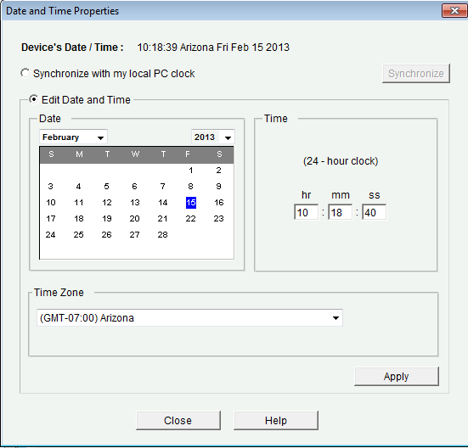

* + 1. In the Router’s clock configured window, click **OK**. In the Date and Time Properties window, click **Close**.
  1. Add a new user account to the local database.
     1. In the left navigation pane, select **Router** > **Router Access** > **User Accounts/View** to display the Additional Tasks > User Accounts/View screen in the content pane on the right. Click the **Add…** button.

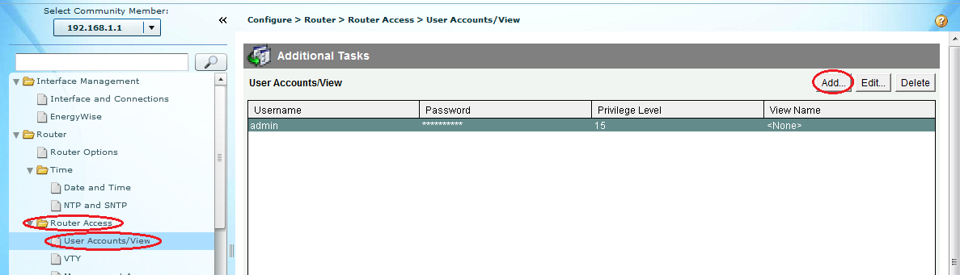

* + 1. Enter **ccpadmin** in the Username: field. Enter **ciscoccppass** in the New Password: and Confirm New Password: fields. Select **15** in the Privilege Level: drop-down list. Click **OK** to add this user to the local database.

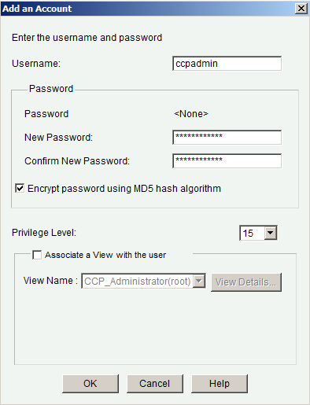

* + 1. In the Deliver Configuration to Device window, click the **Save running config to device’s startup config** check box, and then click **Deliver**.
    2. Review the information in the Commands Delivery Status window, and click **OK**. The new user account should now appear in the content pane on the right.

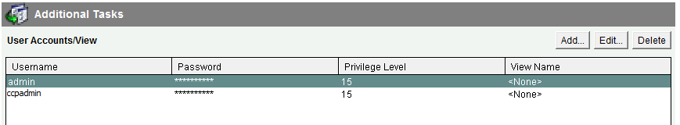

* 1. Edit vty line settings.
     1. In the left navigation pane, select **Router Access** > **VTY** to display the Additional Tasks > VTYs screen in the content pane on the right. Click **Edit…**.

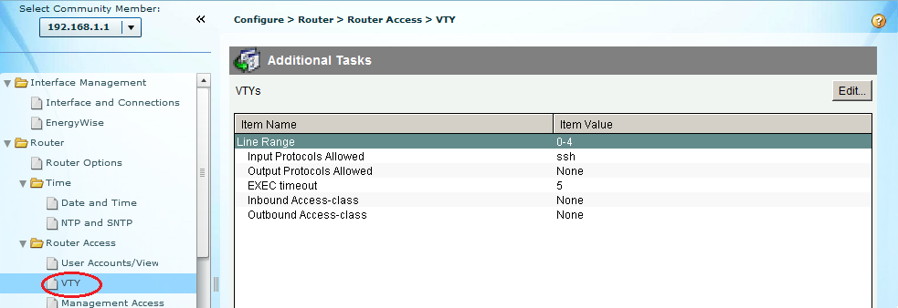

* + 1. In the Edit VTY Lines window, change the Time out: field to **15** minutes. Click the **Input Protocol** > **Telne**t check box. Review the other options available. Also select the **SSH** checkbox. Then click **OK**.

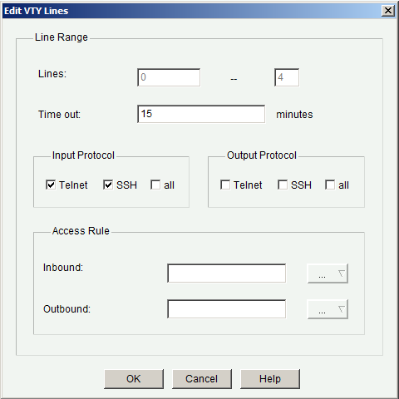

* + 1. Review the commands that will be delivered to the running configuration on the Deliver Configuration to Device screen and click **Deliver**. In the Commands Delivery Status window, click **OK**. The content pane on the right should reflect the changes to the EXEC timeout value.

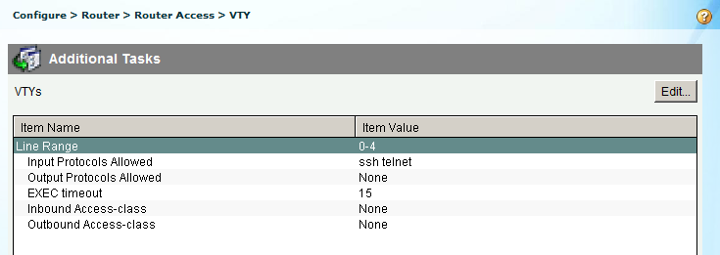

1. Use CCP Utilities

In Part 6, you will use the Utilities pane to save the router’s running configuration to the startup configuration. The Ping utility will be used to test network connectivity, and the View utility will be used to show the router’s running configuration. Finally, you will close CCP.

* 1. Save the router’s running configuration to the startup configuration.
     1. At the bottom of the left navigation pane, locate the Utilities pane. Click **Write to Startup Configuration**.

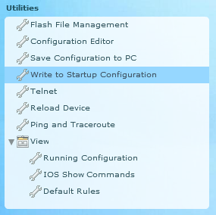

* + 1. The content pane displays a confirmation screen. Click **Confirm**. An Information window displays, letting you know that the configuration was saved successfully. Click **OK**.
  1. Use the Ping utility to test connectivity to PC-B.
     1. In the Utilities pane, click **Ping and Traceroute** to display the Ping and Traceroute screen in the content pane. Enter **192.168.0.3** in the Destination*: field and then click **Ping**. Use the scrollbar to the right of the results box to view the results of your ping.

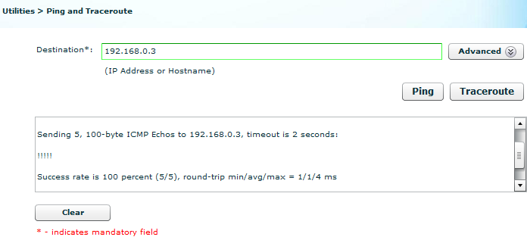

* 1. Use the View utility to show the running configuration for the router.
     1. In the Utilities pane, click **View** > **IOS Show Commands** to display the IOS Show Commands screen in the content pane.

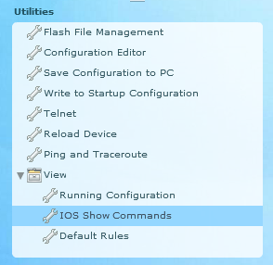

* + 1. Select **show run** from the drop-down list and click **Show**. The router’s running configuration is displayed in the content pane.

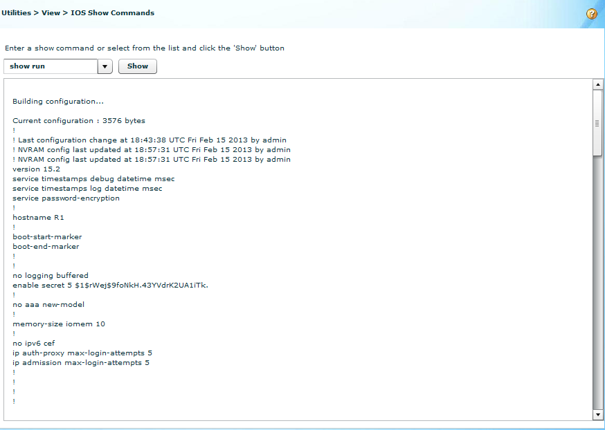

* 1. Close CCP.

Close the CCP window. When a Windows Internet Explorer confirmation window displays, click **Leave this page**.

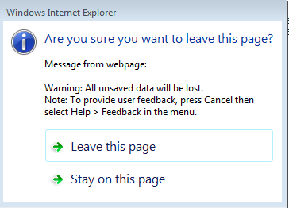

1. Reflection
   1. What transport protocol does CCP use to access the router and what commands are used to allow access?

_______________________________________________________________________________________

_______________________________________________________________________________________

* 1. What router command tells CCP to use the local database to authenticate?

_______________________________________________________________________________________

* 1. What other **show** commands are available in the Utilities pane of CCP?

_______________________________________________________________________________________

_______________________________________________________________________________________

* 1. Why would you want to use CCP instead of the IOS CLI?

_______________________________________________________________________________________

_______________________________________________________________________________________

_______________________________________________________________________________________

1. Router Interface Summary Table

|  |  |  |  |  |
| --- | --- | --- | --- | --- |
| Router Interface Summary | | | | |
| Router Model | Ethernet Interface #1 | Ethernet Interface #2 | Serial Interface #1 | Serial Interface #2 |
| 1800 | Fast Ethernet 0/0 (F0/0) | Fast Ethernet 0/1 (F0/1) | Serial 0/0/0 (S0/0/0) | Serial 0/0/1 (S0/0/1) |
| 1900 | Gigabit Ethernet 0/0 (G0/0) | Gigabit Ethernet 0/1 (G0/1) | Serial 0/0/0 (S0/0/0) | Serial 0/0/1 (S0/0/1) |
| 2801 | Fast Ethernet 0/0 (F0/0) | Fast Ethernet 0/1 (F0/1) | Serial 0/1/0 (S0/1/0) | Serial 0/1/1 (S0/1/1) |
| 2811 | Fast Ethernet 0/0 (F0/0) | Fast Ethernet 0/1 (F0/1) | Serial 0/0/0 (S0/0/0) | Serial 0/0/1 (S0/0/1) |
| 2900 | Gigabit Ethernet 0/0 (G0/0) | Gigabit Ethernet 0/1 (G0/1) | Serial 0/0/0 (S0/0/0) | Serial 0/0/1 (S0/0/1) |
| **Note**: To find out how the router is configured, look at the interfaces to identify the type of router and how many interfaces the router has. There is no way to effectively list all the combinations of configurations for each router class. This table includes identifiers for the possible combinations of Ethernet and Serial interfaces in the device. The table does not include any other type of interface, even though a specific router may contain one. An example of this might be an ISDN BRI interface. The string in parenthesis is the legal abbreviation that can be used in Cisco IOS commands to represent the interface. | | | | |